Ricardo Lopez
7/30/06

The First Hypothesis On What An Economic Transformation Is Using a Complex
Transformation As A Metaphor

Once again the author’s friends have challenged him to communicate an important idea; this time the idea regards economic processes. Among the multitude of different economic phenomenon only one concerns the author (implicitly bounded by the challenge) of this short essay; the transformation of an economy such that the context in which different activity existing in that economy is changed. The author has also decided to be ambitious enough to communicate the necessity of such an event. Just like the need to prepare different materials before one can build any type of edifice; the author shall discuss some topics that may not initially seem relevant to the subject under discussion. However as the essay unfolds (and the Universe continues to be lawful) the reader shall understand the importance of everything in the essay from beginning to end.
Now to paint in the mind of the reader the specific phenomenon the author is attempting to pin-point; the author is going to introduce a transformation in a geometrical space. In particular the transformation in a Complex Plane. Now to illustrate that in fact a change took place in which relationships and characteristics of the geometrical space became different, the author drew what he calls Ricky’s Cat in both spaces. Now let us proceed and look at Ricky’s Cat before the introduction of the transformation.

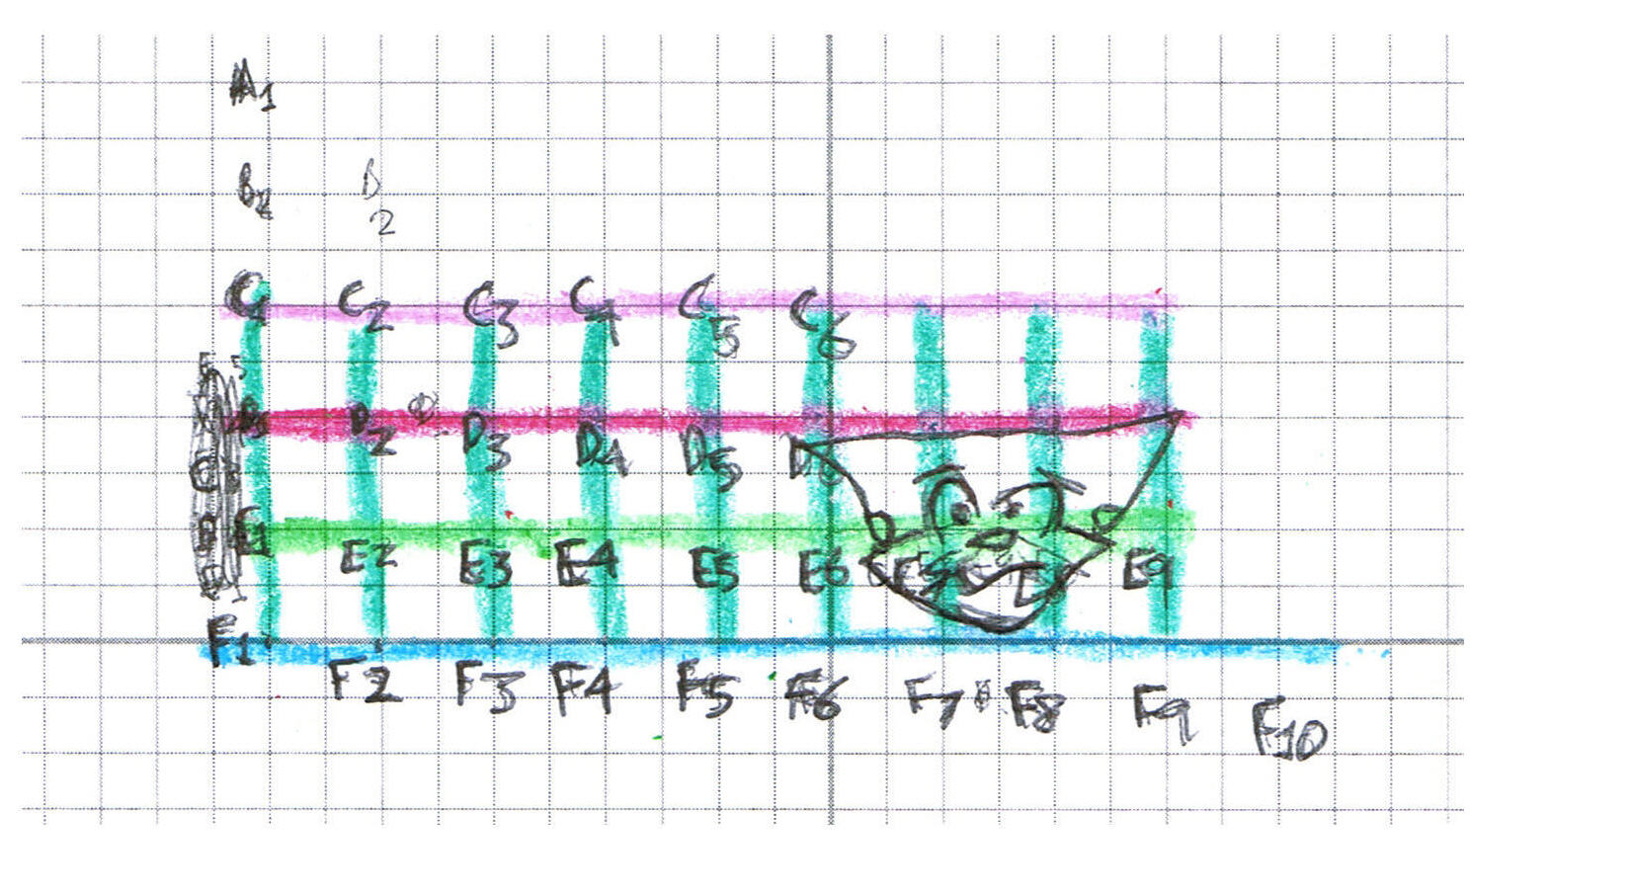
One can notice that the author has denoted the points with a letter and a number. Each point on this grid can be represented by a Complex Number, exempli gratia: E7 is equal to 1 + -1^1/2. The way in which this geometrical space shall be transformed is by multiplying each point by itself, id est, 1 + -1^1/2 shall be multiplied by 1 + -1^1/2. Lo and Behold the new space!----------------
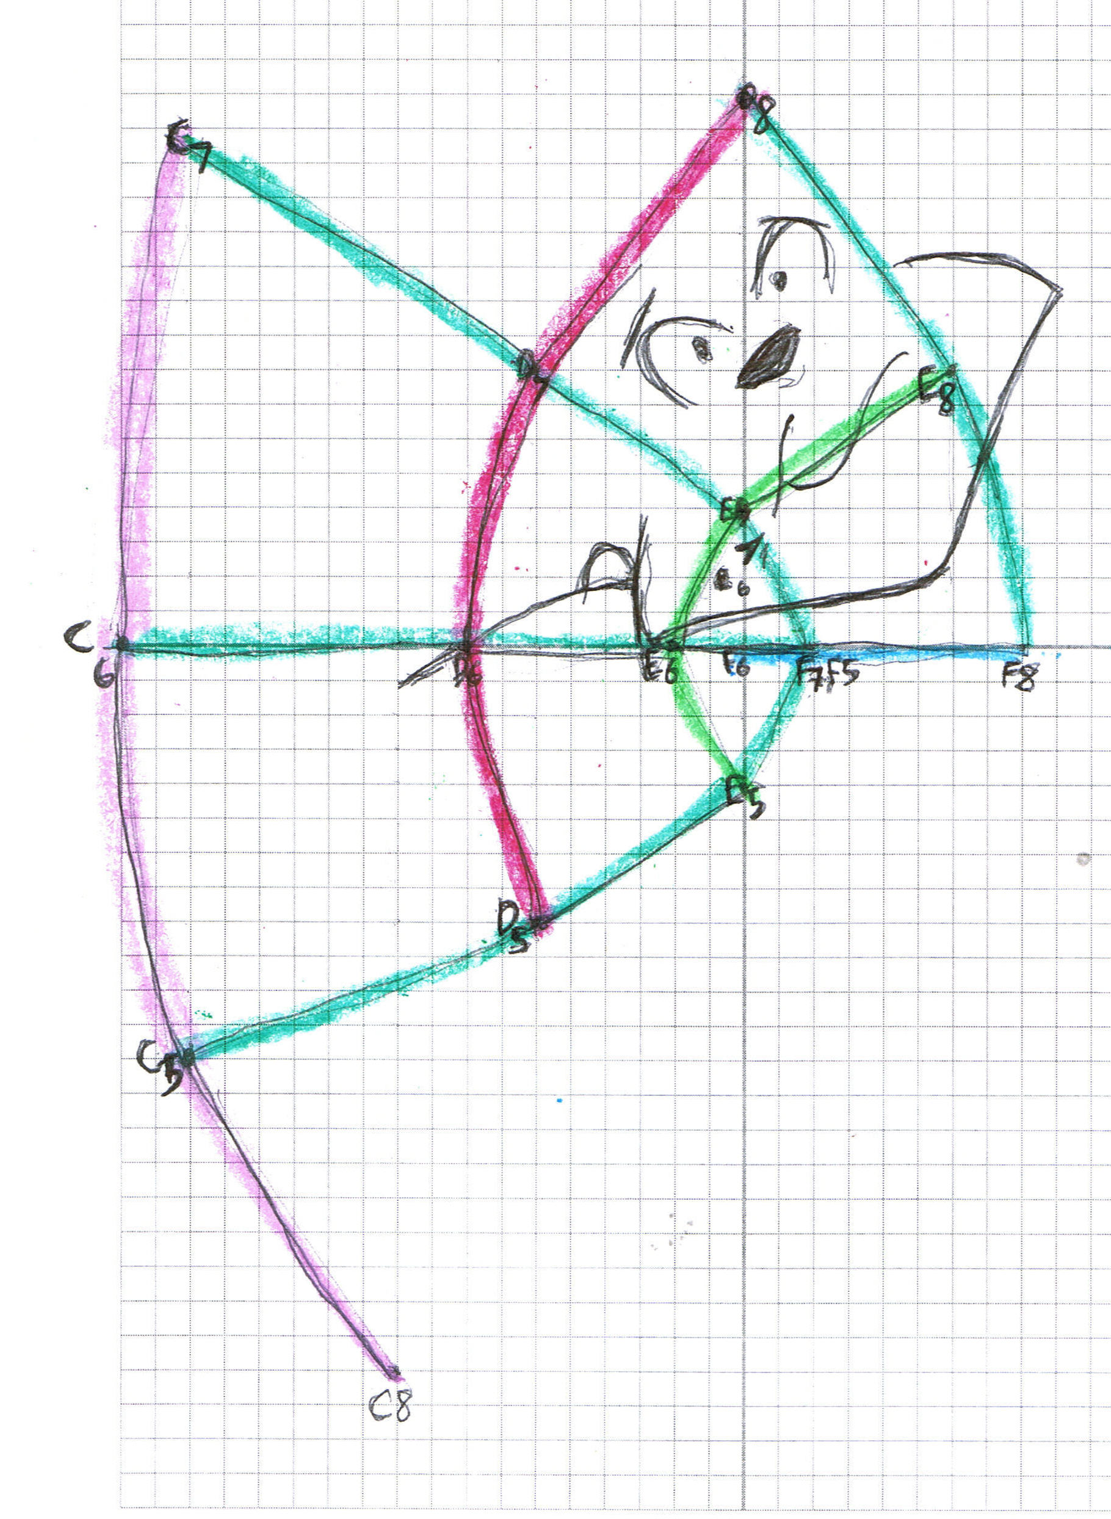

Now one’s mind can notice and conjecture that a transformation took place. The change mostly took place in the context in which Ricky’s Cat finds itself. Henceforth the author shall discuss examples of this Complex Transformation with less abstract and straight forward economic phenomenon.
What can possibly create such a transformation in an economy? Thank God for history and the ability for human beings to jot it down for history provides examples ad infinitum. However so that this essay doesn’t last ad infinitum I shall only give a couple of examples.
The introduction of electricity into an economy provides one with the means to clearly see how the context of an economy is transformed. To understand how the context changed one can look at what new capabilities human beings gained as a result of the introduction of electricity, or in other words, what new things can take place as a result of the introduction of electricity that couldn’t possibly have occurred had it not been introduced. The author must cite an awesome woman to communicate this idea.
The former governor of Washington State Dixie Lee Ray writes in her book, Trashing The Planet , how electricity created the conditions in which refrigeration can be introduced into the economy. She writes, “When I was young, fresh food could be eaten only when in season. Some fruits and vegetables could be preserved by canning, but the processes for safe home canning were poorly understood and unreliable. Food poisoning was common. Every year people were stricken with botulism and salmonella or various digestive upsets caused by eating decayed or tainted food. During the winter, therefore, only potatoes, carrots, cabbage, winter squash, onions and dried beans were generally available. Some people ate rutabagas, turnips, and parsnips, but, in our family, these were considered ‘horse food.’ Only with the introduction of widespread refrigeration of rail cars and boats, warehouses, and grocery food containers could fresh food be brought to the customer throughout the year.”
One more example must be given to communicate the necessity of such economic shifts. When Franklin Delano Roosevelt, one of the best Presidents of the United States, needed to immolate the Nazis, he had to create a transformation in the economy by introducing electricity. He introduced the electricity through the TVA, which built hydroelectric dams. That electricity provided the means to produce the aluminum necessary for the War Airplanes to defeat the Nazis and the Japanese Fascist. Hence, the author thanks God for Franklin Roosevelt’s economic transformation which created the context in which the arsenal to defeat fascism was realized.
This short essay must inevitably conclude and end before it can no longer be considered short by the reader. The idea the author intended to communicate has already been communicated; if the author has failed miserably to communicate an idea to the reader it only means the reader must do more research and the author must continue to improve his capability to communicate (perhaps a transformation is necessary).

Bibliography:

Ray, Lee Dixie. Trashing The Planet. New York: Harper Collins Publishers Inc, 1990.
“From a New Deal to A New Century.” URL: http://www.tva.gov/abouttva/history.htm

Director, Bruce. “Riemann For Anti-Dummies.” URL: http://wlym.com/tiki/tiki-index.php?page=Pedagogicals

To fully understand what a Complex Plane is requires arduous mathematical study that won’t be covered in this essay.However it shall not prevent anyone from understanding the idea that shall be communicated in this essay.

